**Game research**

Games researched

The games I will be looking at are

The binding of Isaac

The Stanley parable

Super Hot

Tiny Wings

The binding of Isaac

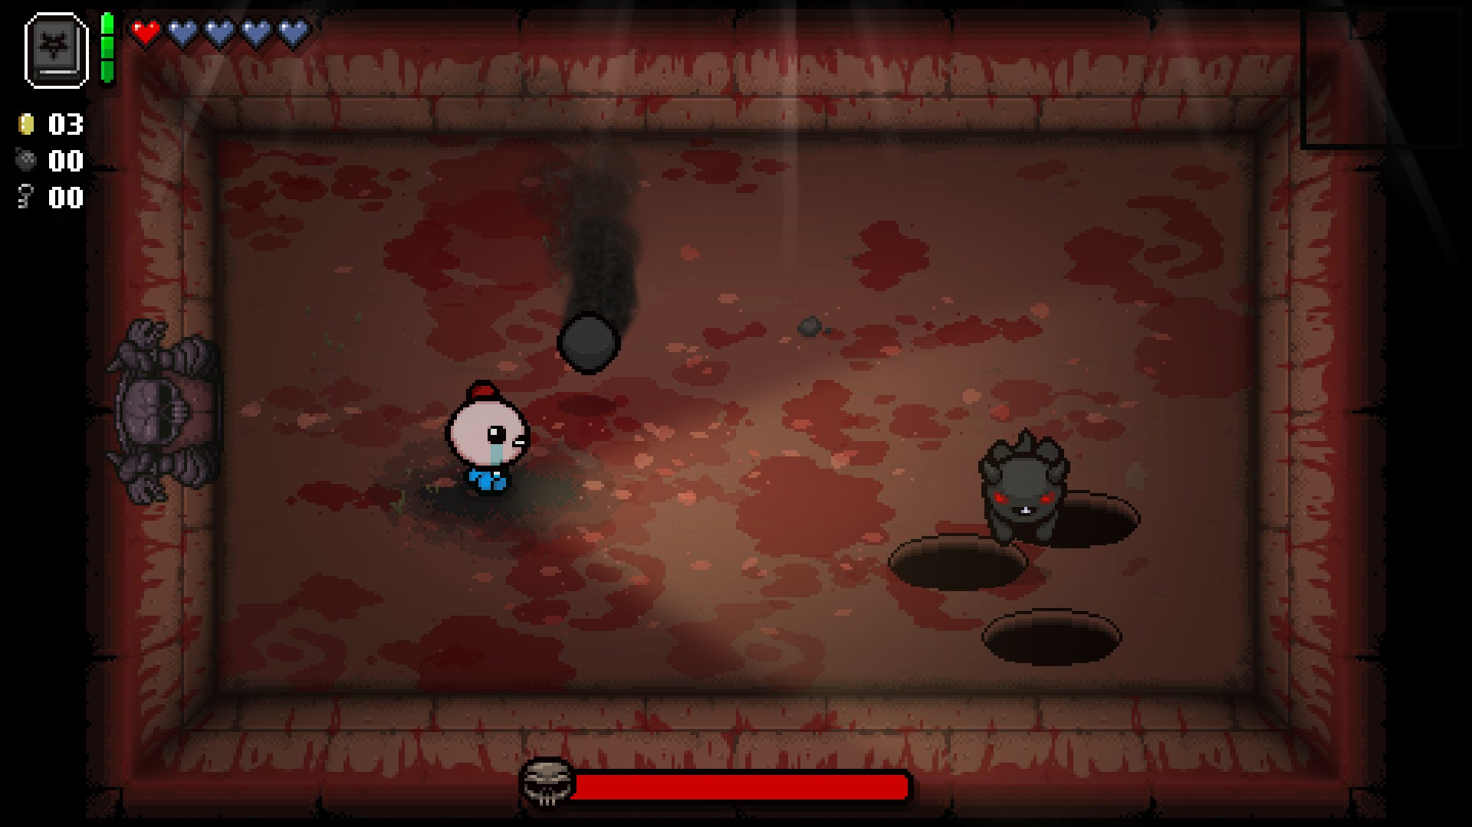

The Binding of Isaac is pretty much infinitely repayable. All the levels and all of the Items are randomly generated meaning that each time you play you will get a different experience.

While this is a unique mechanic I don’t think this is suitable for our project, as we don’t have that long and creating random generation I think will end up taking to much of our time.

The Stanley parable

The Stanley parable is very good at changing the game world without you noticing. You can be walking around a corner tans then when you turn back around it’s not where you came from.

Super hot

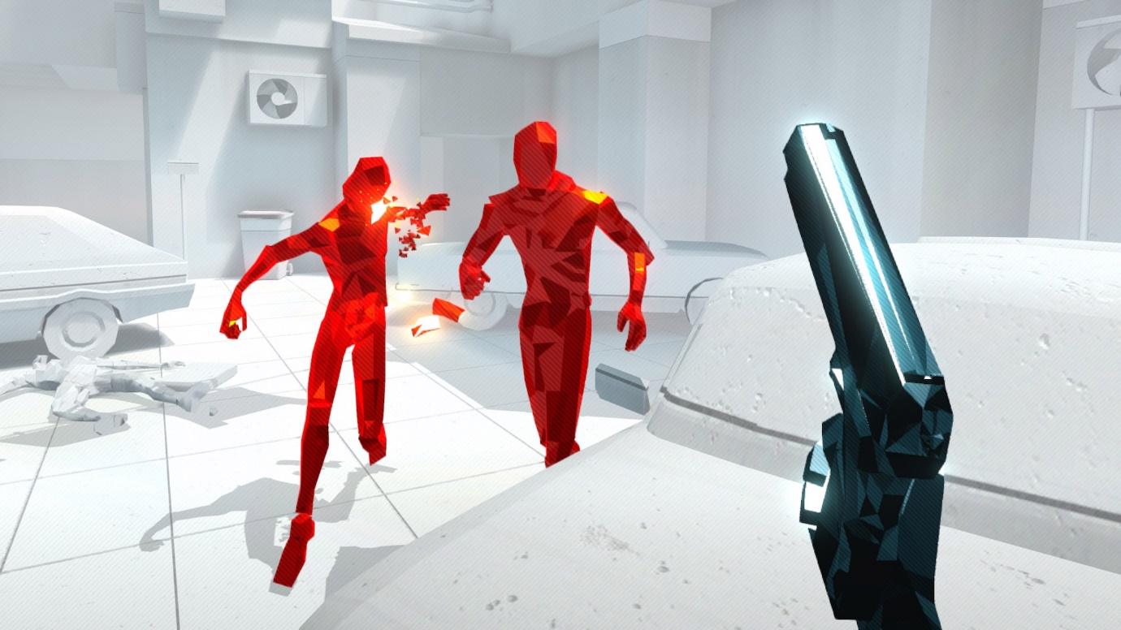

With Super Hot time moves only when you move giving the player longer to decide This gives a unique twist on to the first person shooter genre.

Tiny wings

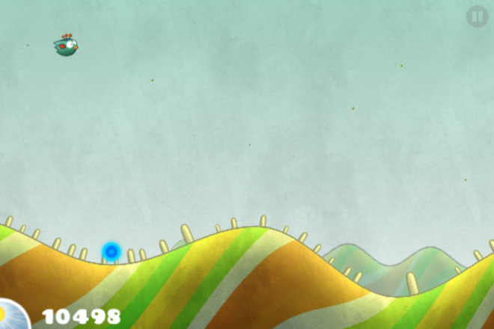

Tiny wings is a mobile momentum game where you have to get as far as you can before night falls. To get as far as possible you have to time screen presses in order to send your bird down to the ground, you then need to time this on a slope so you can get the momentum to send the bird back into the sky.

I like this mechanic as it involves the player mastering one technique to get them further in the game.

**Game themes and ideas**

Top down 2.5d game

You are a pig on a farm who is trying to free the other animals from the evil farmer

The freeing of the animals would be based around a single mechanic.

It would involve the player completing different actions and not getting caught be the farmer to progress in the game.

The main mechanic possibly would be sneaking to avoid the farmer